ENGLISH-3 OVERALL
TEST
1. Ты услышишь три диалога. В каждом из случаев 1 - 5 поставь значок "+", если дети об этом говорили, и значок "-", если нет. Ты услышишь диалоги два раза.

1) about a new house
2) about the summer holidays
3) about new friends at school

4) about the weather

5) about a new doll

2. Для каждого из слов 1 - 10 выбери верный вариант перевода.
1) to celebrate a) праздновать b) украшать c) готовить
2) шутка a) a camp b) a yard c) a joke
3) fifteen a) 15 b) 20 c) 50
4) мыть a) to clean b) to wash c) to feed
5) beautiful a) добрый b) счастливый c) прекрасный
6) a dress a) штаны b) платье c) юбка
7) frosty a) морозный b) ветреный c) дождливый
8) руки a) legs b) hands c) ears
9) a hamster a) свинья b) черепаха c) хомяк
10) июнь a) June b) July c) May
3. Переведи слова в скобках с русского на английский.

1) He gave (мне) a ball.
2) Misty (должна) find her doll.
3) (Весна) is a warm season.
4) This is a gift (для) my father.
5) My friends know about (них).
6) They (часто) spend time together
4. Выбери для каждого из пропусков в предложениях 1 - 10 подходящий вариант заполнения.
1) ____ we go to the stadium. a) Tomorrow b) Yesterday c) Sometimes
2) ____ eyes are green. a) Jakes b) Jake's c) Jake'
3) You should ____ the paths. a) sweep b) to sweep c) sweeping
4) Yesterday we ____ a card. a) made b) maked c) make
5) Did Helen ____ her sister last month? a) visited b) visit c) visiting
6) Tomorrow Tom ___ stay at home. a) don't b) won't c) didn't
7) We ___ decorate our house last week. a) wasn't b) hadn't c) didn't
8) ___ does your friend live? a) Where b) What c) When
9) It ___ sunny today. a) has b) is c) was
10) Next week we ___ a party. a) have b) had c) will have

5. Прочитай текст про Юфо и его друзей и кратко ответь на вопросы 1 - 6 после него.

Ufo and his friends
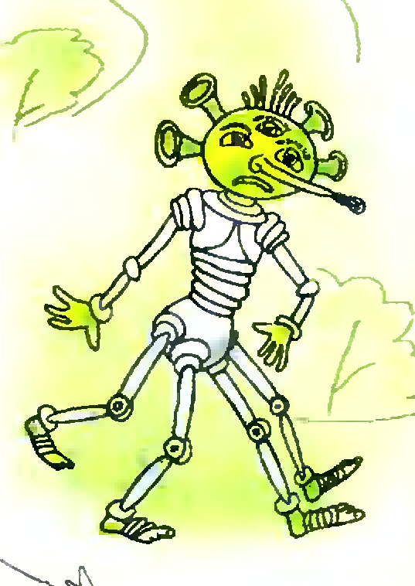
Ufo didn't have friends. He was very sad. One day in May he went to find friends. He walked on and on in the forest.
Soon he saw a little grey mouse. The mouse said: "Good morning, Ufo! Please take me with you!" "Who are you?" "I am a little mouse. My name is Mary. I have got a funny hat." "Come with me!"
So Ufo and the little mouse walked together. Then they saw a happy pig. The happy pig said: "Good morning! Please take me with you!" "Who are you?" "I am a happy pig! My name is Peter! I can dance" "Come with us!"
So Ufo, Mary the mouse and Peter the pig walked on together. Soon they saw a smart rabbit. The smart rabbit said: "Good morning! Please take me with you!" "Who are you?" "I am a smart rabbit! My name is Martin. I count very well" "Come with us! Tomorrow we will play together"
1) Was Ufo very happy?
2) When did Ufo go to find friends?
3) What colour was Mary?
4) What was the pig's name?
5) Did Ufo see the smart rabbit?
6) Will Ufo and his new friends play together?
6. Заполни пропуски в предложениях 1 - 6 информацией о себе. В скобках есть подсказки.
1) My name is ________.
2) I am from ______. (country)
3) I have got _________. (about your family)
4) I like to wear _______. (your favourite clothes)
5) I like to eat ______. (your favourite tasty food)
6) I can ________ very well.
ENGLISH-3 OVERALL
TEST - TEACHER’S PAPER
Текст для аудирования
Первый диалог
- Helen, where will you go in August?
- I don’t know, I think I will go to my grandparents. I want to spend my summer holidays on their farm.
- May I go with you?
- Fine, I will be happy.
Второй диалог
- Mary, is it your parents’ birthday gift?
- Yes, it is. Do you like it?
- Yes, I do! I like this doll a lot. It’s beautiful! What’s its name?
- Linda.
Третий диалог
- Where are you from?
- I’m from India. And the Russian winter is very cold for me.
- And what is the weather like in India?
- It’s warm and sunny in my country.
ОТВЕТЫ И БАЛЛЫ
1.
1 | 2 | 3 | 4 | 5
- | + | - | + | +
Каждый верный ответ – 1 балл. Всего – 5 баллов.
2.
1 | 2 | 3 | 4 | 5 | 6 | 7 | 8 | 9 | 10
a | c | a | b | c | b | a | b | c | a
Каждый верный ответ – 1 балл. Всего – 10 баллов.
3.
1 | 2 | 3 | 4 | 5 | 6
me | must | Spring | for | them | often
Каждый верный ответ – 1 балл. Всего – 6 баллов.
4.
1 | 2 | 3 | 4 | 5 | 6 | 7 | 8 | 9 | 10
c | b | a | a | b | b | c | a | b | c
Каждый верный ответ – 1 балл. Всего – 10 баллов.
5.
1 | 2 | 3 | 4 | 5 | 6
No, he wasn’t | in May | grey | Peter | Yes, he did. | Yes, they will.
Каждый верный ответ – 1 балл. Всего – 6 баллов.
6. Каждое правильно (лексически и грамматически) дополненное предложение – 1 балл. Всего – 6 баллов.
ИТОГО: 43 балла
Перевод баллов в оценку:
39 - 43 балла – “5”
25 - 38 баллов – “4”
13 - 24 балла – “3”
менее 13 баллов – “2”

