ENGLISH-4 OVERALL
TEST
1. Ты услышишь 5 мини-диалогов Дэвида и его учителя мисс Лэйк. Каждому диалогу соответствует вопрос. В каждом случае выбери ответ-картинку из вариантов a - c. Ты услышишь мини-диалоги два раза.
№ | Question | a | b | c
1 | What time did David go to school? |  | 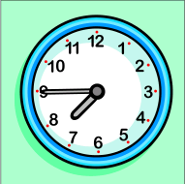 | 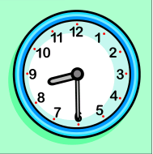
2 | Which is Sally's desk? | 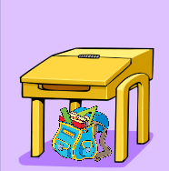 | 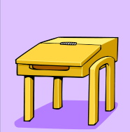 | 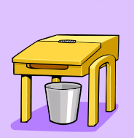
3 | What subjects will the class study soon?
4 | Where should David put the book? | 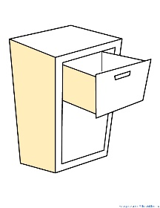 | 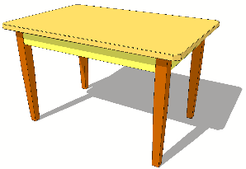 | 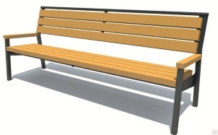
5 | Where will the teacher’s meeting be? |  | 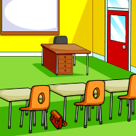
2. Для каждого из описаний 1 - 6 подбери подходящее слово из рамки. Два слова в рамке лишние.
a snake a cafe a pencil a fridge a door a sportsman a watch a bus

1) We draw with it.
2) He can ran very fast.
3) It's in the kitchen.
4) A driver drives it.
5) It's a dangerous animal.
6) We can eat there.

3. Выбери верный вариант для заполнения пропусков.
1) It was the ___ day in my new school. a) one b) first c) eleven
2) ___ worry, please! a) Doesn't b) Didn't c) Don't
3) I'm ___ breakfast now. a) having b) had c) have
4) I get ___ at six o'clock. a) down b) up c) to
5) It's the ___ beautiful town. a) most b) more c) many
6) We have ___ a big change. a) maked b) make c) made
7) My doll is ___ than your car. a) good b) best c) better
8) My sister ___ going to be a vet. a) is b) am c) are
4. Соотнеси реплики в диалогах.
1) Thank you for the apple! | a) Sweet dreams!
2) You have taken my ruler! | b) I can't find my snack.
3) I'll go to bed. | c) Excuse me.
4) I'm the tallest boy in our school! | d) Enjoy your meal!
5) What's wrong? | e) Really?
5. Прочитай текст и заполни пропуски в предложениях 1 - 6 словами из текста. В каждом случае используй только одно слово.
Linda's hobby
My name is Linda. I like toys, but I like books more. I love stories about men on the moon and about children who live in different countries.
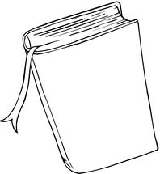
I read a good story yesterday. In this story, a boy climbed a mountain. At the top, there was a lot of snow. It was evening, but the boy could see the forest around him. He sat down on the ground to have a drink and to look up at all the stars. But then he saw the thing that he didn’t understand. It was very big and round. It was behind a cloud. What was it? The boy didn’t know and he didn’t wait to see it again. He ran home to his parents because he was very afraid.
I wasn’t afraid! I enjoyed the story a lot!

1) Linda likes ___ more than toys.
2) There was some ___ at the top.
3) The boy saw the ___ around him.
4) There were many ___ in the sky.
5) The thing wasn't little, it was ___.
6) The boy didn't want to ___ the thing.
6. Прочитай рассказ Нила. Используя его историю как образец, напиши рассказ о своём любимом диком животном.
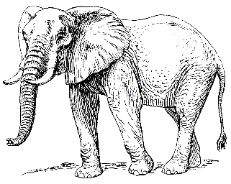
I'm Neil. My favourite wild animal is an elephant. I saw it in the zoo. It has got two big ears and four strong legs. Its colour is grey. Usually the elephants live in Africa and in India. I like them because they are very kind and smart.
ENGLISH-4 OVERALL
TEST - TEACHER’S PAPER
Мини-диалоги для аудирования
Мини-диалог 1.
Miss Lake: Good morning, David.
David: Good morning, Miss Lake.
Miss Lake: You’re early for school today. It’s only eight and a half.
David: Well, my mum's got a new job, so I must go to school at a quarter to eight.
Мини-диалог 2.
Miss Lake: Sally left her book in the library. Can you put it on her desk, please?
David: Yes, but which is her desk?
Miss Lake: It's that one, near the door.
David: This one?
Miss Lake: No, there's a bag under Sally's desk.
Мини-диалог 3.
David: Is that all, then, Miss Lake?
Miss Lake: Yes, it is, I think.
David: What lessons have we got today?
Miss Lake: Umm ... music and art.
David: Great! And history?
Miss Lake: No, that's tomorrow.
Мини-диалог 4.
Miss Lake: Oh, here's something else for you to do.
David: Yes?
Miss Lake: Can you get the book out of the cupboard,
David: Ok! Where should I put it... on the table?
Miss Lake: Yes, please.
Мини-диалог 5.
David: It's fun to help you. Can I do it again tomorrow morning?
Miss Lake: No, thank you. I'm going to go to a meeting tomorrow.
David: Is that in our classroom?
Miss Lake: No. It's in the teachers' room.
David: Ok! So I can go to the library tomorrow morning.
Miss Lake: Yes, you are free! And thanks for helping today!
ОТВЕТЫ И БАЛЛЫ
1.
1 | 2 | 3 | 4 | 5
b | a | b | b | c
Каждый верный ответ – 1 балл. Всего – 5 баллов.
2.
1 | 2 | 3 | 4 | 5 | 6
a pencil | a sportsman | a fridge | a bus | a snake | a cafe
Каждый верный ответ – 1 балл. Всего – 6 баллов.
3.
1 | 2 | 3 | 4 | 5 | 6 | 7 | 8
b | c | a | b | a | c | c | a
Каждый верный ответ – 1 балл. Всего – 8 баллов.
4.
1 | 2 | 3 | 4 | 5
d | c | a | e | b
Каждый верный ответ – 1 балл. Всего – 5 баллов.
5.
1 | 2 | 3 | 4 | 5 | 6
books | snow | forest | stars | big | see
Каждый верный ответ – 1 балл. Всего – 6 баллов.
6.
Письменный рассказ по образцу оценивается по критериям структуры, содержания и языкового оформления из максимума в 5 баллов.
ИТОГО: 35 баллов

Перевод баллов в оценку:
32 - 35 баллов – “5”
21 - 31 балл – “4”
11 - 20 баллов – “3”
менее 11 баллов – “2”

